Written Resolution of Kirklees College Corporation

Passed on 16 September 2024

In accordance with clause 15 of the Corporation’s Instrument of Government, the following resolution was duly passed by way of written resolution:

- To appoint Professor Peter Roberts to the Kirklees College Corporation as an Independent Governor and member of the Kirklees College Finance & Resources Committee.

- To appoint Sophie Johnson to the Kirklees College Corporation as an Independent Governor and member of the Kirklees College Safeguarding Committee for a term of four years.

- To appoint Brendan Brown to the Kirklees College Curriculum Strategy Committee as a Co-optee in the first instance and to the Corporation as an Independent Governor when a seat becomes available.

- To appoint Andrew Fell to the Kirklees College Audit Committee as a Co-optee.

- To appoint Marcus Smith-Connor to the Kirklees College Curriculum Strategy Committee as a Co-optee.

Each appointment is for a term of for a term of four years, commencing on the date of the first meeting attended, or the date of any Kirklees College new Governor induction training attended, whichever is the sooner.

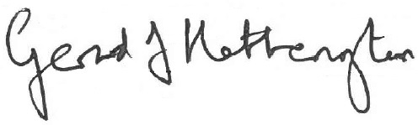

Signed by Chair

Date: 16 September 2024

