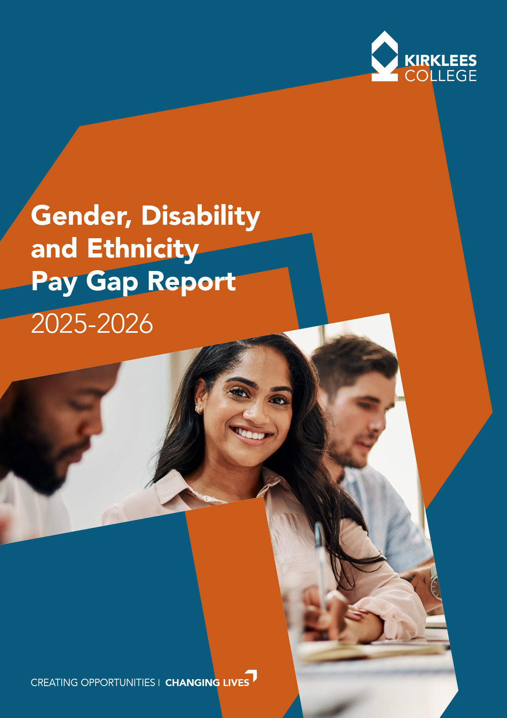

Kirklees College Gender, Disability and Ethnicity Pay Gap Report 2025-2026

Introduction
At Kirklees College, our commitment to equality, diversity, and inclusion are at the heart of our mission of "Creating Opportunities, Changing Lives." We strive to create an environment where every student and staff member can reach their full potential, embracing the richness of a diverse community. We are dedicated to fostering a culture of kindness, unity, and excellence, while working to remove barriers that limit equal opportunities for all.

To comply with the Equality Act 2010 (Gender Pay Gap Information) Regulations, UK organisations with over 250 employees are required to publish their gender pay gap data annually. This legislation, introduced in 2017, seeks to increase transparency around pay disparities and drive action to close any gaps.

At Kirklees College, we not only meet this statutory requirement but exceed it by voluntarily reporting on both our Ethnicity Pay Gap and Disability Pay Gap. This approach reflects our values and our commitment to addressing inequality wherever it exists, helping us continue to remove barriers and create an inclusive, equitable environment for everyone.

This report sets out our Gender Pay Gap, Ethnicity Pay Gap, and Disability Pay Gap.

Context

What do we mean when we refer to a pay gap?

A ‘pay gap’ is different from ‘equal pay.’ Equal pay refers to ensuring that individuals, regardless of gender, disability, or ethnicity, receive the same pay for the same or equivalent work. In other words, if two people are doing the same job or jobs of similar value, they must be paid equally.

In contrast, a 'pay gap' measures the difference in average earnings between different groups within an organisation. This means looking at the overall distribution of men and women, people with disabilities, and those from different ethnic backgrounds across all roles and levels of the organisation, rather than comparing individuals doing the same job.

For example, a gender pay gap reflects the difference in average pay between men and women in the organisation, not whether men and women doing the same job are paid equally. Similarly, the ethnicity and disability pay gaps measure the difference in average pay between different ethnic groups and between employees with and without disabilities.

Why do organisations have a pay gap?

Organisations have gender pay gaps for several reasons and many are rooted in broader societal issues. One key factor is unpaid caring responsibilities. Women are more likely than men to take on the role of unpaid carers, whether for children, elderly parents, or other family members. This can lead to career interruptions, part-time work, or even leaving employment altogether, which directly impacts earnings. The high cost of childcare also influences decisions, with many women reducing their working hours or leaving the workforce due to these expenses. Research has consistently shown that women bear a disproportionate share of caregiving, which in turn affects their career progression and pay.

Another significant factor is occupational segregation. Certain industries and roles are dominated by either men or women, and jobs that are traditionally held by women, such as caring, cleaning, and clerical work tend to be lower paid. This is not just about men and women doing different work but also about the undervaluation of jobs commonly performed by women. While efforts like the National Living Wage help raise pay in lower-paid sectors, they do not address the underlying issues of job value or equality in career advancement.

The challenges are not limited to gender; pay gaps also exist for disabled people, ethnic minorities, and other demographic groups. These gaps often result from higher representation in part-time or lower-paid roles, difficulties in career progression, and barriers to remaining in or returning to employment.

By understanding the root causes, organisations can begin addressing pay disparities in a meaningful way.

What information must be reported?

The gender pay gap reporting rules require organisations to publicly disclose pay and employment data using six measures:

Mean gender pay gap | The difference between the average hourly rate of pay of male employees and female employees.
Median gender pay gap | The difference between the middle hourly rate of pay for male employees and female employees.

Mean bonus pay gap | The difference between the average bonus pay paid to male employees and that paid to female employees, during the year ending on the snapshot date, 31st March.
Median bonus pay gap | The difference between the middle bonus pay paid to male employees and paid to female employees.
Bonus proportions | The proportions of male and female relevant employees who received a bonus during the relevant period.
Quartile pay bands | The proportions of male and female employees in the lower, lower middle, upper middle and upper quartile pay bands.
CIPD

Pay Gap Data
Snapshot date: 31 March 2025

Our Gender Pay Gap:

Gender Pay Gap | 2024 | 2025 | 2026 | 3 Year Trend
Mean Pay Gap% | 7 | 9 | 8
Median Pay Gap % | 20 | 22 | 24

Gender Pay Quartile Data:

Year | 2024 |  | 2025 |  | 2026 |  | Trend
Quartile Values | Male | Female | Male | Female | Male | Female
Lower | 25% | 75% | 22.5% | 77.5% | 20.0% | 80.0%
Lower-Middle | 26% | 74% | 28.3% | 71.7% | 31.5% | 68.5%
Upper-Middle | 39% | 61% | 39.8% | 60.2% | 37.1% | 62.9%
Upper | 38% | 63% | 42.6% | 57.4% | 41.6% | 58.4%

Our mean (average) pay gap has decreased by 1% and our median (middle) pay gap has increased by 2%, when compared to last year. Over a three-year period, our mean pay gap has increased by 1% and the median pay gap has increased by 4%.

Our pay gap movements in 2025-2026 primarily reflect changes in workforce composition and distribution rather than any reduction in our commitment to equality. In March 2026, women represented 67.5% of our overall workforce but accounted for 80% of employees in the lower pay quartile. While women continue to be represented across all pay quartiles, they remain underrepresented in the upper pay quartile, where they make up 58.4% of employees.

Between 2025 and 2026, our workforce increased by 26 employees, with almost all of this growth within the female workforce. This included an increase of 11 women in the lower quartile, 11 in the upper-middle quartile and 6 in the upper quartile. The increase in female representation within the higher-paid quartiles has contributed positively to the reduction in the mean pay gap. However, the continued concentration of women in lower-paid roles has a greater influence on the midpoint of pay distribution and has contributed to the increase in the median pay gap.

The imbalance in our gender profile across quartiles reflects a wider sector pattern, with roles in education more heavily occupied by women due to gender segregation within the labour market. Many women are concentrated in the 'five Cs' - caring, cleaning, catering, clerical, and cashiering - roles that are typically lower paid, which helps explain why we continue to see a higher proportion of women in lower-paid positions within our organisation. In addition, the unequal division of caring responsibilities leads to more women taking part-time roles, which generally offer lower wages. These issues are not unique to our organisation but mirror broader societal trends in the labour market.

Our Ethnicity Pay Gap

Ethnicity Pay Gap | 2024 | 2025 | 2026 | Trend
Mean Pay Gap % | 7 | 6 | 5
Median Pay Gap % | 19 | 18 | 20

Ethnicity Pay Quartile Data:

Year | 2024 |  | 2025 |  | 2026 |  | ONS Data
Quartile Values | White | All other ethnic groups | White | All other ethnic groups | White | All other ethnic  groups | 73.6% of  the Kirklees community is white
Lower | 62% | 38% | 55% | 45% | 53% | 47% | 73.6% of  the Kirklees community is white
Lower-Middle | 76% | 24% | 72% | 28% | 67% | 33% | 73.6% of  the Kirklees community is white
Upper-Middle | 77% | 23% | 72% | 28% | 73% | 27% | 73.6% of  the Kirklees community is white
Upper | 77% | 23% | 72% | 28% | 66% | 34% | 73.6% of  the Kirklees community is white

Our average (mean) pay gap has continued to improve, reducing by a further 1% from last year. The median pay gap, however, has increased slightly compared with 2025. Over recent years, the mean pay gap has shown a positive downward trend, while the median pay gap has remained more variable.

During the year, the workforce became more ethnically diverse, with the proportion of staff from non-white backgrounds increasing from 32.2% to 35.1%. We saw increased representation across all pay quartiles, including growth in the upper quartile, where non-white headcount increased by 16. This improvement in representation at the higher end of the pay structure, together with stronger growth in average hourly pay for non-white staff, contributed to the reduction in the mean pay gap.

Despite this progress, non-white staff remain disproportionately represented in lower-paid roles. While non-white employees account for 35.1% of the overall workforce, they represent 46.8% of staff in the lower pay quartile. Although representation in the upper quartile increased to 34.0%, broadly reflecting overall workforce representation, continued concentration within the lower half of the pay distribution has contributed to the increase in the median pay gap.

The increase in ethnic diversity across the workforce is welcome and demonstrates continued progress in building a more representative organisation. However, the distribution of staff across pay quartiles highlights the importance of continuing to understand and address the barriers and structural inequalities that can result in staff from ethnically diverse backgrounds being overrepresented in lower-paid roles and underrepresented in higher-paid positions.

Our Disability Pay Gap

Disability Pay Gap | 2024 | 2025 | 2026 | Trend
Mean Pay Gap% | 3 | 1 | 0
Median Pay Gap % | 2 | 4 | 8

Disability Pay Quartile Data:

Year | 2024 |  | 2025 |  | 2026 |  | ONS  Data
Quartile | Non- | Disabled | Non- | Disabled | Non- | Disabled
Values | Disabled |  | Disabled |  | Disabled |  | 17.5% of the
Lower | 91% | 9% | 91% | 9% | 92% | 8% | 17.5% of the
 |  |  |  |  |  |  | Kirklees
Lower- | 90% | 10% | 90% | 10% | 89% | 11% | community is
Middle |  |  |  |  |  |  | Is disabled
Upper-Middle | 91% | 9% | 91% | 9% | 90% | 10%
Upper | 91% | 9% | 91% | 9% | 92% | 8%

The mean disability pay gap further reduced this year to 0.2%, while the median pay gap increased to 8.1%. The reduction in the mean gap reflects stronger average pay growth for disabled staff, while the increase in the median gap is influenced by changes in the distribution of disabled colleagues across the pay quartiles.

As of March 2026, 9.3% of our staff (93 individuals) identified as disabled, remaining broadly consistent with the previous year. Representation continues to be distributed across all pay quartiles, demonstrating that disabled colleagues are present across all levels of the College. However, representation is highest within the lower-middle quartile and lowest within the upper quartile.

The disabled population remains relatively small, meaning that modest changes in headcount can have a noticeable impact on pay gap calculations, particularly the median. During the year, there was a slight reduction of disabled staff within the upper quartile and an increase in the lower-middle quartile. This contributed to a reduction in the mean hourly rate for disabled staff. At the same time, disabled staff in the upper quartile continued to achieve higher average and median hourly rates than their non-disabled colleagues, helping to keep the overall mean pay gap close to zero.

While representation among disabled colleagues has remained stable, it remains below the local community benchmark of 17.5%, indicating there is still more work to do to ensure our workforce is fully representative of the community we serve. We remain committed to creating an inclusive workplace where disabled colleagues can access opportunities and thrive at all levels of the organisation.

Bonus Pay Gap

For the purposes of this report, bonus payments include payments that meet the statutory definition of a bonus. Within the College, these payments are typically limited to long service awards, employee recruitment referral bonuses. As bonus payments are relatively uncommon, the bonus pay gap calculations are based on a small number of payments and can be significantly influenced by the value and distribution of individual awards.

A total of 43 employees received a bonus payment during the 12 months to the snapshot date, representing 3.8% of the workforce. This included 3 recruitment referrals and 40 long service awards.

The mean gender bonus pay gap is 70.4%, with men receiving an average bonus payment of £124.06 compared to £36.67 for women. The median gender bonus pay gap is 40.0%, based on median bonus payments of £50.00 for men and £30.00 for women. Whilst more women received a bonus payment overall (27 women compared to 16 men), the average value of payments made to men was higher.

The ethnicity bonus pay gap presents a different picture. The mean bonus pay gap is -77.5%, indicating that the average bonus payment received by non-white employees (£110.83) was higher than that received by white employees (£62.43). However, this result is based on only six non-white employees receiving a bonus payment, compared with 37 white employees. The median ethnicity bonus pay gap is 25.0%, as the typical bonus payment received by white employees remained slightly higher.

The disability bonus pay gap also shows a negative mean gap of -123.0% and a negative median gap of -66.7%. Disabled employees who received a bonus payment received a higher average bonus (£135.00) than non-disabled employees (£60.53). Again, these figures are influenced by the very small number of employees receiving bonuses, with only five disabled employees receiving a payment during the reporting period.

The comparatively large bonus pay gaps reported across all protected characteristics are primarily driven by the low number of bonus payments made during the year and the impact of a small number of higher-value awards. Unlike the hourly pay gap, which is calculated using the earnings of the whole workforce, the bonus pay gap calculations are based only on employees who received a bonus. Consequently, a small number of payments can have a disproportionate impact on the reported results, causing significant fluctuations.

Action to Reduce Our Pay Gap
Closing the pay gap remains a priority. As a restorative, anti-racist, and inclusive college, our mission of Creating Opportunities, Changing Lives is grounded in diversity, equality, and inclusion. We are committed to removing barriers so every student and staff member can reach their potential, supported by the richness of our diverse community.

We are an inclusive employer, leading with purpose and grounded in our values. Our focus on DEI is reflected in the experiences of our staff and students with 95% of colleagues and 94% of students reporting that people from different backgrounds, faiths or beliefs are made to feel welcome.

The following work supports our efforts to reduce our pay gap:

Fair Pay Practices
We ensured all roles were paid at least the Voluntary Living Wage, reflecting our commitment to fair pay. This approach particularly benefits lower-paid roles and strengthens our long-term progress in reducing systemic pay inequalities.

Strategic Focus
The Single Equality Scheme (2025–2029) ensures we focus on actions that will have the greatest impact in achieving equality. It provides a clear framework for monitoring progress and addressing disparities across different characteristics, including pay gaps.

Recruitment and Selection
We take deliberate steps to ensure fair and inclusive hiring and attract diverse talent. Applications are anonymised to remove EDI information, and all recruitment managers complete EDI training. Equality, diversity, and inclusion are assessed throughout the selection process to ensure we appoint candidates who will contribute to a culture of inclusion and belonging. Salaries are advertised for transparency, with each role assigned a defined pay grade or pay point. We also engage with local job fairs to encourage more people from the Kirklees community to apply for roles with us.

Equality Impact Assessments
We will maintain our practice of equality impact assessing all key strategies and policies to identify and remove potential barriers to accessing employment, experiencing positive employment, and achieving equal access to opportunities.

Flexible Working
We will continue to offer and support flexible working requests, where organisational needs allow us to retain talented employees who may have taken breaks due to family or carer responsibilities. This ensures equality of opportunity for career progression on a part-time basis.

Priorities for the Year Ahead
In the year ahead, we are committed to driving measurable actions through our EDI action plan that directly address disparities identified in pay gap reporting. Our priorities will focus on two core areas:

Exploring the Equality Impact of Employment Decisions
We will review key employment decisions, including recruitment, performance, and dismissal, to identify trends or patterns that may highlight areas for further exploration. This helps us understand whether any groups of workers could face barriers or inequities.

- We will continue to strengthen our links with the Black Leadership Group. Having engaged regularly with their training throughout the year, we will also seek to incorporate their research and guidance to further enhance inclusive recruitment practices.

